**Capstone Project - The Battle of Neighborhoods**

**Opening Italian Restaurant in Vadodara**

**1. Introduction**

**1.1 Background**

Vadodara District is a district in the eastern part of the state of Gujarat in western India. The city of Vadodara (Baroda), in the western part of the district, is the administrative headquarters. Vadodara District covers an area of 7,794 km². As of 2011, the district had a population of 4,165,626 of which 49.6% were urban, 50.4% were rural, 5.3% were scheduled castes and 27.6% were scheduled tribes.[6] As of 2011 it is the third most populous district of Gujarat (out of 33), after Ahmadabad and Surat.[1]

The district is bounded by Panchmahal district to the north, Anand and Kheda districts to the west, Bharuch and Narmada districts to the south, and Chhota Udaipur to the east. The Mahi River passes through the district.

The historical city of Baroda was the capital of Baroda Residency, and one of the princely states of India under Bombay Presidency.

**1.2. Problem**

In this project, I will investigate that if there is any good location in Vadodara for opening Italian

restaurant and it really values to open one.

**1.3. Interest**

Anyone wants to open a new venue in any geographic location may be interested in this project by modifying search criteria.

**2. Data**

**2.1 Data sources**

To consider the problem we can list the data as below:

I get the neighborhood data of vadodara from Wikipedia [3]

<https://en.wikipedia.org/wiki/Vadodara>

<https://vmc.gov.in/development_plant.aspx>

<https://www.proptiger.com/vadodara/all-localities>

* I use python geocoder library to get geographical coordinates of neighborhoods[4]
* I use **Foursquare API** **venues explore** method to get the venues of given neighborhoods of vadodara [5].
* I use **Foursquare API venues method** to get ranks and likes of restaurants by given venue id [5].

**A. References:**

[3]<https://en.wikipedia.org/wiki/Vadodara>

[4] [Python Geocoder Library](https://geocoder.readthedocs.io/)

[5] [Foursquare API](https://developer.foursquare.com/)

**2.2 Feature Selection and Data Usage**

I will use neighborhood location values to analyze vadodara geographical structure. I will use folium library of python to draw maps by using given latitude and longitudes of neighborhoods. Selected features will be as below

I will use populations of neighborhoods who has big population may need a new restaurant.

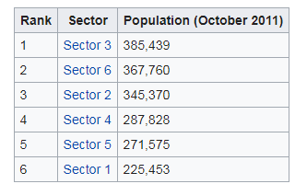 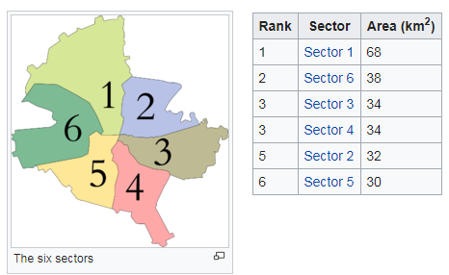

I will also classify neighborhoods by using venues distribution and counts. In this way, I will find similarities of neighborhoods which will help me to choose location for opening a new restaurant. Similar structured neighborhoods may handle same type of venue.

I will use venue list category to find distribution of restaurants and Italian restaurants in neighborhoods.

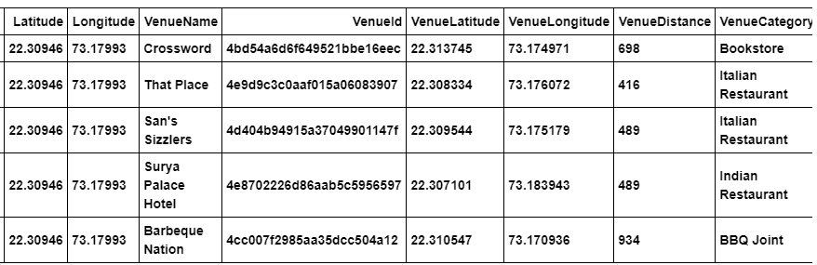

I will use also ratings and likes of restaurants in the areas. It may help me to find location with bad rating restaurants which may need a new restaurant.

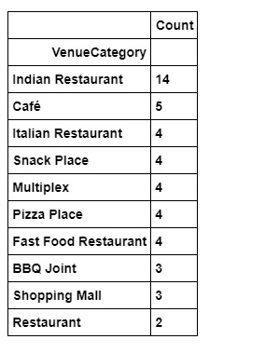

After that I will use clustering methods to produce sector wise distribution of venues.As shown in the figure below.

